**Project development phase**

**SPRINT -1**

|  |  |
| --- | --- |
| Team ID | PNT2022TMID50747 |
| Project Name | Smart waste management system for metropolitan cities |

**HTML CODE:**

<!DOCTYPE html>

<html lang="en">

<head>

<meta charset="UTF-8" />

<meta name="viewport" content="width=device-width, initial-scale=1.0" />

<title>Smart Waste Management System</title>

<!-- Bootstrap 4 CSS CDN -->

<link rel="stylesheet" href="https://cdnjs.cloudflare.com/ajax/libs/twitter-bootstrap/4.5.2/css/bootstrap.min.css" /> <!--

Fontawesome CSS CDN -->

<link rel="stylesheet" href="https://cdnjs.cloudflare.com/ajax/libs/font-awesome/5.14.0/css/all.min.css" />

<link rel="stylesheet" href="css/style.css" />

</head>

<body class="bg-info">

<div class="container">

<!-- Login Form Start -->

<div class="row justify-content-center wrapper" id="login-box">

<div class="col-lg-10 my-auto myShadow">

<div class="row">

<div class="col-lg-7 bg-white p-4">

<h1 class="text-center font-weight-bold text-primary">Sign in</h1>

<hr class="my-3" />

<form action="#" method="post" class="px-3" id="login-form">

<div class="input-group input-group-lg form-group">

<div class="input-group-prepend">

<span class="input-group-text rounded-0"><iclass="far fa-envelope fa-lg fa-fw"></i></span> </div>

<input type="email" id="email" name="email" class="form-controlrounded-0" placeholder="E-Mail" required /> </div>

<div class="input-group input-group-lg form-group">

<div class="input-group-prepend">

<span class="input-group-text rounded-0"><iclass="fas fa-key fa-lg fa-fw"></i></span>

</div>

<input type="password" id="password" name="password" class="form -control rounded-0" minlength="5" placeholder="Password"

required autocomplete="off" />

</div>

<div class="form-group clearfix">

<div class="custom-controlcustom-checkboxfloat-left">

<input type="checkbox" class="custom-control-input" id="customCheck" name="rem" />

<label class="custom-control-label" for="customCheck">Remember me</label> </div>

<div class="forgot float-right">

<a href="#" id="forgot-link">Forgot Password?</a> </div>

</div>

<div class="form-group">

<input type="submit" id="login-btn" value="Sign In" class="btn btn-primary btn-lg btn-block myBtn" />

</div>

</form>

</div>

<div class="col-lg-5 d-flex flex-column justify-content-center myColor p-4"> <h1

class="text-center font-weight-bold text-white">Welcome Friend!</h1>

<hr class="my-3 bg-light myHr" />

<p class="text-center font-weight-bolder text-light lead">Start your initiative to make your environment clean</p>

<button class="btn btn-outline-light btn-lg align-self-center font-weight-bolder mt-4 myLinkBtn" id="register-link">Sign Up</button>

</div>

</div>

</div>

</div>

<!-- Login Form End -->

<!-- Registration Form Start -->

<div class="row justify-content-center wrapper" id="register-box" style="display: none;">

<div class="col-lg-10 my-auto myShadow">

<div class="row">

<div class="col-lg-5 d-flex flex-column justify-content-center myColor p-4">

<h1 class="text-center font-weight-bold text-white">Welcome Back!</h1>

<hr class="my-4 bg-light myHr" />

<p class="text-center font-weight-bolder text-light lead">To stay connected Please login with your personalinfo.</p>

<button class="btn btn-outline-light btn-lg font-weight-bolder mt-4 align-self-center myLinkBtn" id="login-link">Sign In</button>

</div>

<div class="col-lg-7 bg-white p-4">

<h1 class="text-center font-weight-bold text-primary">Create Account</h1>

<hr class="my-3" />

<form action="#" method="post" class="px-3" id="register-form">

<div class="input-group input-group-lg form-group">

<div class="input-group-prepend">

<span class="input-group-text rounded-0"><iclass="far fa-user fa-lg fa-fw"></i></span> </div>

<input type="text" id="name" name="name" class="form-controlrounded-0" placeholder="Full Name" required /> </div>

<div class="input-group input-group-lg form-group">

<div class="input-group-prepend">

<span class="input-group-text rounded-0"><iclass="far fa-envelope fa-lg fa-fw"></i></span> </div>

<input type="email" id="remail" name="email" class="form-control rounded-0" placeholder="E-Mail" required /> </div>

<div class="input-group input-group-lg form-group">

<div class="input-group-prepend">

<span class="input-group-text rounded-0"><iclass="fas fa-key fa-lg fa-fw"></i></span>

</div>

<input type="password" id="rpassword" name="password" class="form -control rounded-0" minlength="5" placeholder="Password"

required />

</div>

<div class="input-group input-group-lg form-group">

<div class="input-group-prepend">

<span class="input-group-text rounded-0"><iclass="fas fa-key fa-lg fa-fw"></i></span>

</div>

<input type="password" id="cpassword" name="cpassword" class="form -control rounded-0" minlength="5" placeholder="Confirm

Password" required />

</div>

<div class="form-group">

<div id="passError" class="text-danger font-weight-bolder"></div>

</div>

<div class="form-group">

<input type="submit" id="register-btn" value="Sign Up" class="btn btn-primary btn-lg btn-block myBtn" />

</div>

</form>

</div>

</div>

</div>

</div>

<!-- Registration Form End -->

<!-- Forgot Password Form Start -->

<div class="row justify-content-center wrapper" id="forgot-box" style="display: none;">

<div class="col-lg-10 my-auto myShadow">

<div class="row">

<div class="col-lg-7 bg-white p-4">

<h1 class="text-center font-weight-bold text-primary">Forgot Your Password?</h1>

<hr class="my-3" />

<p class="lead text-center text-secondary">To reset your password, enter the registered e-mail adddress and we will send you password

reset instructions on your e-mail!</p>

<form action="#" method="post" class="px-3" id="forgot-form">

<div id="forgotAlert"></div>

<div class="input-group input-group-lg form-group">

<div class="input-group-prepend">

<span class="input-group-text rounded-0"><iclass="far fa-envelope fa-lg"></i></span> </div>

<input type="email" id="femail" name="email" class="form-control rounded-0" placeholder="E-Mail" required />

</div>

<div class="form-group">

<input type="submit" id="forgot-btn" value="Reset Password" class="btn btn-primary btn-lg btn-block myBtn" />

</div>

</form>

</div>

<div class="col-lg-5 d-flex flex-column justify-content-center myColor p-4">

<h1 class="text-center font-weight-bold text-white">Reset Password!</h1>

<hr class="my-4 bg-light myHr" />

<button class="btn btn-outline-light btn-lg font-weight-bolder myLinkBtn align-self-center" id="back link">Back</button>

</div>

</div>

</div>

</div>

<!-- Forgot Password Form End -->

</div>

<!-- jQuery CDN -->

<script src="https://cdnjs.cloudflare.com/ajax/libs/jquery/3.5.1/jquery.min.js"></script>

<script src="js/script.js"></script>

</body>

</html>

**CSS CODE :**

@import url("https://fonts.googleapis.com/css?family=Maven+Pro:400,500,600,700,800,900&display=swap");

* { margin: 0; padding: 0; box-sizing: border-box;

font-family: "Maven

Pro", sans-serif;

}

.wrapper

{ height: 100vh;}

.myColor

{ background-image: linear-gradient(to right, #324bf3 50%, #f9d423 150%);

}

.myShadow { box-shadow: 0 10px rgba(0, 0,

0, 0.5);

}

.myBtn { border-radius: 50px; font-weight: bold; font-size: 20px;

background-image: linear-gradient(to right, #0acffe 0%, #495aff 100%);

border: none;

}

.myBtn:hover { background-image: linear-gradient(to right, #495aff 0%,

#0acffe 100%);

}

.myHr { height: 2px; border-radius:

100px;

}

.myLinkBtn { borderradius:

100px; width: 50%;

border: 2px

solid #fff;

}

@media (max-width: 720px) {

.wrapper {

margin: 2px;

} }

**JS CODE:**

$(function () {

$("#register-link").click(function () {

$("#login-box").hide();

$("#register-box").show();

});

$("#login-link").click(function () {

$("#login-box").show();

$("#register-box").hide();

});

$("#forgot-link").click(function () {

$("#login-box").hide();

$("#forgot-box").show();

});

$("#back-link").click(function () {

$("#login-box").show();

$("#forgot-box").hide();

});

});

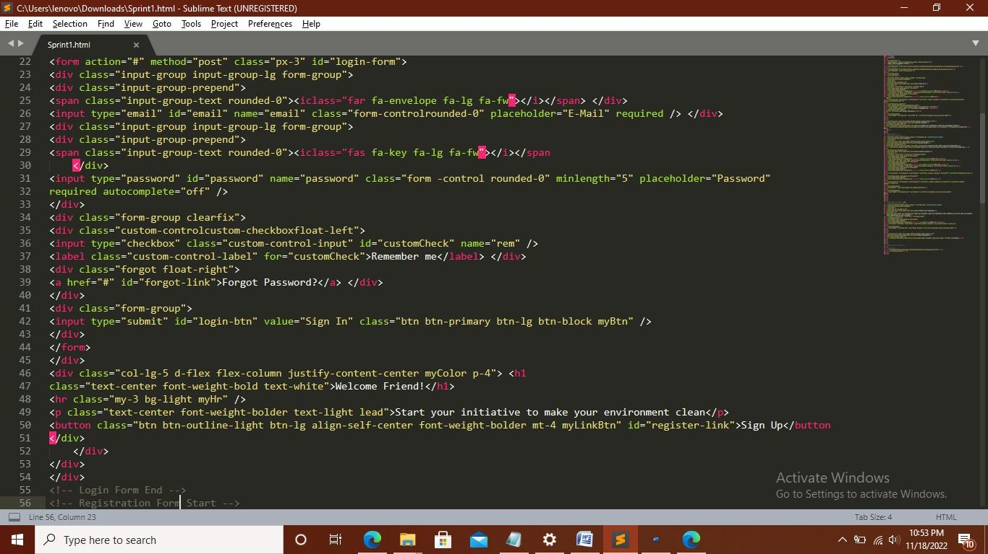**OUTPUT :**

